Practical 17 Manual Form Creation

- Code the following one button form. Make the exit button work.
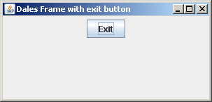
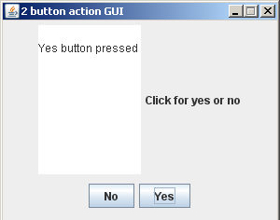
- Code the following 2 buttoned action form

- Create the DogYears GUI. To convert dog years to human years multiply by 7. You will need to set the focus to the Dog Years text field.

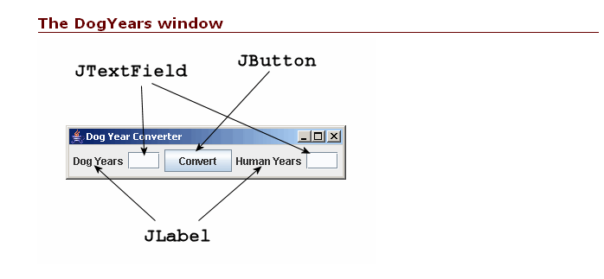
My labels are the wrong way round- have the human years first, set the focus to this field
- Manually create the following form. The hardest part of this form is the layout, force components together by putting them on their own panels, I would have a panel for the every label and it’s text box. FlowLayout will run left to right top to bottom depending on the size of the frame. Do not make the frame resizeable if you are relying on a fixed size to display your components neatly.
